Construction Site Progress Capture
UX Mockups and Interaction Specification
Document owner | Version | Date | Status
Michael Yaacoub, Sr Solution Engineer | 1.0 | 2026-08-24 | Draft

This template follows the sample UX pack: each SCR screen pairs a visual mockup with a specification panel, and the pack closes with a navigation-flow map.

1. Experience Overview
The primary user is a site engineer walking the works with a tablet under one arm, in a hard hat and gloves, in bright sun or a dark core, with no signal for hours at a time. Quantity surveyors and commercial managers work the same record from a site office or head office. Design principles: capture where the work is, because anything deferred to the office is reconstructed; tie evidence to the package at the moment it is taken; make the daily record quick enough that it is genuinely done daily; and never let a subcontractor see another's position.
Persona | Primary goal | Device / viewport | Usage context
Site engineer | Record what was built today, with evidence, without going back to the office | Site tablet, 10 inch, in a rugged case | Live construction site, gloved, hard hat, bright sun or dark cores, no signal
Quantity surveyor | Prepare a valuation from captured fact and answer any challenge from the record | Web, 1440 pixels and wider | Site office at period end, working thousands of measured items

2. Screen Inventory
Screen ID | Screen name | Mapped feature | User goal | Primary action
SCR-01 | Work Package List | FEAT-01 | Find the package being worked today | Open the package
SCR-02 | Progress and Evidence Capture | FEAT-02 | Record what was built, where it was built | Save the progress entry
SCR-03 | Daily Site Record | FEAT-03 | Record the facts of the day while they are facts | Lock the daily record
SCR-04 | Valuation and Approval | FEAT-04 | Value what was built and get it approved | Approve the valuation

3. Screen Mockups and Specifications

3.1 SCR-01 Work Package List
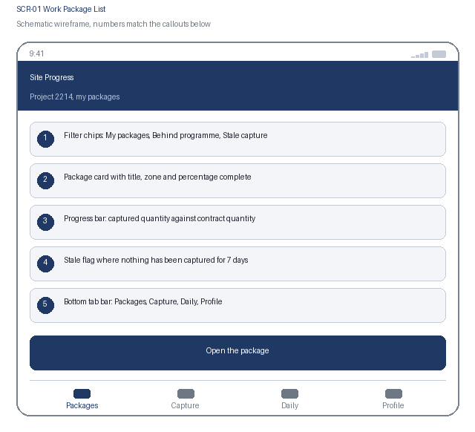  1. Filter chips: My packages, Behind programme, Stale capture  2. Package card with title, zone and percentage complete  3. Progress bar: captured quantity against contract quantity  4. Stale flag where nothing has been captured for 7 days  5. Bottom tab bar: Packages, Capture, Daily, Profile | Specification panel  Purpose: The engineer finds the work package for the area being worked and sees where it stands before recording anything.  Primary action: Open the package, which lists its measured items ready for capture.  Data: Package title, zone and level, measured item count, captured and contract quantity, percentage complete, last capture date. Source: progress service over the commercial package cache.  States: Loading, current, stale capture, behind programme, offline, cached and marked with age  Roles: Engineers see their project; subcontractors see only their own packages; commercial sees all  Requirements: US-101, US-102, NFR-001, NFR-004

3.2 SCR-01 Interaction Details
Element / callout | Behavior | Validation | Accessibility
1. Filter chip | Filters in place and keeps scroll position; one chip active at a time | An empty result names the active filter | Radio buttons in a labelled group with the selected state announced
2. Package card | Opens the package with its measured items | None | One link whose accessible name combines package title, zone and percentage complete
3. Progress bar | Shows captured against contract quantity for the package | None | The figure is stated as text beside the bar, so the bar is never the only indicator
4. Stale flag | Appears where no capture has been recorded for 7 days | The flag distinguishes no progress from no recording, and states which it cannot tell apart | Announced as text explaining the flag's meaning rather than shown as an icon alone

3.3 SCR-02 Progress and Evidence Capture
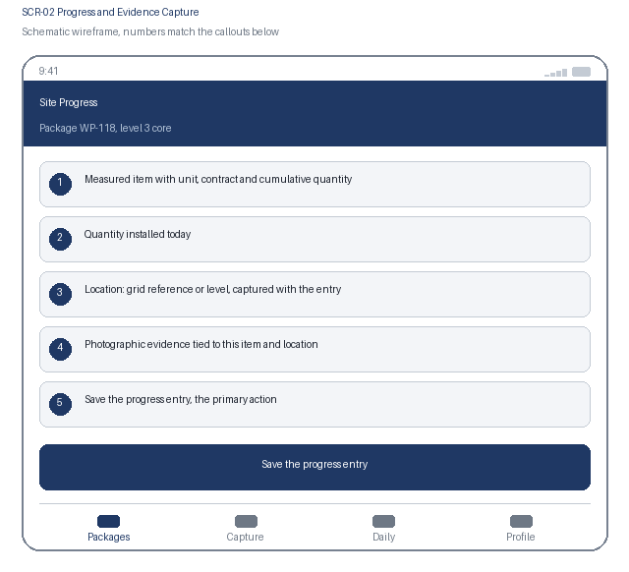  1. Measured item with unit, contract and cumulative quantity  2. Quantity installed today  3. Location: grid reference or level, captured with the entry  4. Photographic evidence tied to this item and location  5. Save the progress entry, the primary action | Specification panel  Purpose: The engineer records the quantity installed against the measured item at the point of work, with the evidence attached where it happened.  Primary action: Save the progress entry, which records the quantity, location and evidence against the item.  Data: Measured item description and unit, contract quantity, cumulative captured quantity, quantity today, grid reference or level, photographs with capture time and location. Source: progress service.  States: In progress, exceeds contract quantity, variation referenced, evidence attached, queued offline, saved  Roles: Engineers capture for their own packages; commercial reads; nobody edits a saved entry  Requirements: US-201, US-202, NFR-003, NFR-006

3.4 SCR-02 Interaction Details
Element / callout | Behavior | Validation | Accessibility
1. Quantity field | Numeric entry with the unit shown and the cumulative total updating live | A cumulative total exceeding the contract quantity is blocked until a variation reference is supplied | The cumulative total is announced through a polite live region as the entry changes
2. Location capture | Records the grid reference or level, offered from the device position where available | Location is mandatory; a position outside the project boundary requires confirmation | Manual entry always available; the captured source is stated as device or manual
3. Evidence capture | Opens the camera and links the photograph to this item and location | At least one photograph is required on any entry above the evidence threshold for the item type | The requirement is stated before capture; each thumbnail prompts for a short description used as alternative text
4. Save the progress entry | Commits the quantity, location and evidence | Blocked while a required evidence item or the location is missing, with each item named | Confirmation states that the entry contributes to a valuation and cannot be edited afterwards

3.5 SCR-03 Daily Site Record
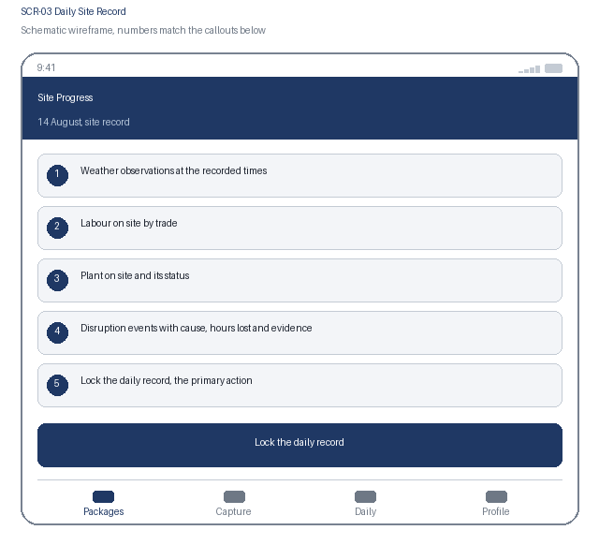  1. Weather observations at the recorded times  2. Labour on site by trade  3. Plant on site and its status  4. Disruption events with cause, hours lost and evidence  5. Lock the daily record, the primary action | Specification panel  Purpose: At the end of the shift the engineer completes the day's record, which then locks and becomes the contemporaneous account of what happened.  Primary action: Lock the daily record, which fixes the day and prevents any later edit.  Data: Weather observations with times, labour counts by trade, plant items and status, disruption events with cause, affected packages, hours lost, instruction reference and photographs. Source: progress service.  States: Open, partially complete, disruption recorded, locked, late entry, offline  Roles: Engineers complete their own site day; project manager reviews; nobody edits after lock  Requirements: US-301, US-302, NFR-002, NFR-006

3.6 SCR-03 Interaction Details
Element / callout | Behavior | Validation | Accessibility
1. Weather observation | Records conditions at the defined observation times | Each required observation time must be completed before the day can lock | Outstanding observations are listed as text with their times
2. Labour entry | Numeric entry per trade with a running total on site | Counts must be zero or greater; a total of zero on a working day requires a note | The running total is announced through a polite live region as entries change
3. Disruption event | Captures cause, affected packages, hours lost, instruction reference and photographs | Cause, affected package and hours lost are mandatory; an event without evidence requires an explanation | Each field carries a visible label and the mandatory items are stated before entry
4. Lock the daily record | Fixes the day and prevents further editing | Blocked while a required observation is outstanding, with each one named; a day left unlocked locks automatically at the project cut-off and is marked as such | Confirmation states plainly that the record cannot be edited after locking

3.7 SCR-04 Valuation and Approval
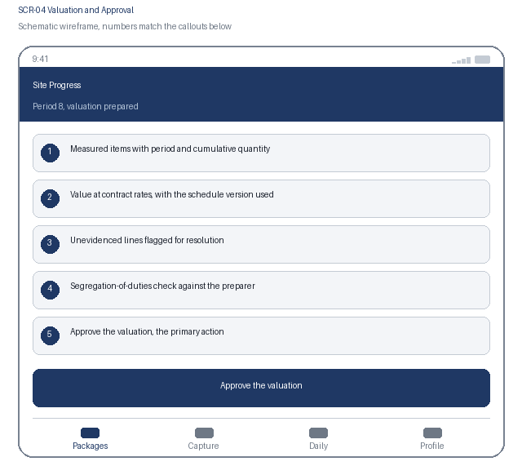  1. Measured items with period and cumulative quantity  2. Value at contract rates, with the schedule version used  3. Unevidenced lines flagged for resolution  4. Segregation-of-duties check against the preparer  5. Approve the valuation, the primary action | Specification panel  Purpose: The quantity surveyor reviews a valuation assembled from captured quantities, resolves anything unevidenced, and a second person approves it.  Primary action: Approve the valuation, which locks it and enables the application pack.  Data: Measured items with period and cumulative quantity, contract rate and schedule version, line value, evidence reference count, unevidenced flags, preparer and approver identity. Source: valuation assembler over the commercial rate schedule.  States: Assembling, assembled, unevidenced lines outstanding, blocked by segregation of duties, approved, pack generated  Roles: Quantity surveyor prepares; a different commercial manager approves; auditor reads  Requirements: US-401, US-402, NFR-004, NFR-006, NFR-007

3.8 SCR-04 Interaction Details
Element / callout | Behavior | Validation | Accessibility
1. Valuation line | Expands to show the contributing progress entries and their evidence | None | Disclosure with expanded state announced; the line reads as a table row with headers
2. Unevidenced flag | Marks any line whose quantity has no supporting evidence | The valuation cannot be approved while a flagged line is unresolved; each must be evidenced or excluded | Flagged lines are listed as text with a count, not conveyed by colour alone
3. Segregation check | Evaluated server side when the approval screen opens | If the approver prepared the valuation, approval is blocked and alternatives are offered | The block explains why in plain language rather than as a permission error
4. Approve the valuation | Locks the valuation and enables the application pack | Blocked while any line is unevidenced or the rate schedule version is unconfirmed, with each blocker listed | Confirmation states the total value and that approval cannot be undone

4. Navigation Flow
From | User action / condition | To | Alternate or error path
SCR-01 | Engineer opens a work package | SCR-02 | Package cached and stale: the age is stated and capture continues against the cached item list
SCR-02 | Engineer saves a progress entry | SCR-02 for the next item, or SCR-03 at end of shift | Cumulative quantity would exceed contract: a variation reference is required before saving
SCR-03 | Engineer locks the daily record | SCR-01 for the next site day | Day left unlocked: it locks automatically at the project cut-off and is marked as a late entry
SCR-04 | Commercial manager approves the valuation | The application pack is generated | Unevidenced lines outstanding, or segregation of duties blocks approval: the valuation stays in prepared state
Flow: SCR-01 Work Package List, select a package, to SCR-02 Progress and Evidence Capture, save, to SCR-03 Daily Site Record at the end of the shift, lock, to SCR-04 Valuation and Approval for the commercial team at period end, and back to SCR-01 for the next day. The bottom tab bar reaches Packages, Capture, Daily and Profile.

5. Responsive Behavior
Viewport | Navigation | Layout | Content priority | Interaction changes
Phone | Bottom tab bar with four primary destinations | Single column, cards stacked in priority order | Measured item and quantity first; contract context and history below | One-handed reach with gloves, large numeric targets, camera in the lower third; no swipe-only path
Tablet | Adaptive left navigation rail | Package list beside the selected item's capture form | Primary list beside the selected item's detail panel | Touch and pointer both supported; hover reveals nothing essential
Web | Persistent left navigation with breadcrumbs | Valuation grid, line detail and evidence gallery in three columns | Dense scanning of many records, with full detail on selection | Full keyboard support with shortcuts for approve and expand; no hover-only affordance

6. States and Content
State | Trigger | Displayed content | Available actions
Loading | A data request is still in flight after 300 ms | Skeleton content preserving the final layout; valuation assembly reports its progress through the item list | Cancel and retry remain available
Empty | A filter, search or assignment returns no records | A plain statement that no packages or lines match, naming the active filter | Clear the filter, or switch to My packages
Error | A request fails, times out, or is rejected by policy | What failed and whether the captured quantity and photographs were kept | Retry, with captured entries always preserved locally
Offline | The device loses network connectivity | A persistent offline banner and a count of entries and photographs waiting to sync | Capture and the daily record continue; valuation assembly requires connectivity and says so

7. Accessibility Requirements
- WCAG 2.2 AA is the conformance target for every screen, including all interactive states and error messaging.
- Every control is reachable in a logical tab order with a visible focus indicator, a programmatic label, and instructions announced before the input rather than only after an error.
- Errors are announced through an assertive live region, name the field, and describe how to correct the problem.
- Text contrast is at least 4.5 to 1 and non-text indicators at least 3 to 1; the interface remains usable at 200 percent text resize and at 320 CSS pixels wide.
- Motion is limited and honours the reduced-motion preference; no information is conveyed by colour alone.
- Touch targets are at least 44 by 44 CSS pixels with adequate spacing, so the interface stays usable with gloves or one hand.
- {Keyboard order, visible focus, labels, instructions, and error announcement behavior}
- {Contrast, text resize, reduced motion, screen-reader, and touch-target expectations}

8. Review and Approval
Reviewer | Role | Decision | Comments | Date
Design lead | UX design authority | Pending | Interaction model and visual specification
Accessibility specialist | Accessibility | Pending | WCAG 2.2 AA conformance evidence
Product owner | Business product owner | Pending | Screen inventory and flow confirmation

